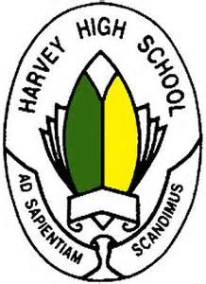
Harvey High School – Dramafest
Thursday January 9th, 2020
david.white@nbed.nb.ca

Dear parents and guardians,

Your child has expressed interest in participating in Dramafest 2020, and we are excited to have them on board! Here is some information about the show, the process, and some important dates moving forward:

- Students have chosen the show 10 Ways to Survive the Zombie Apocalypse by Don Zolidis, which is a one-act series of vignettes tied together by two narrators. A script was sent home today and it is very important that students do not lose their scripts!

- We will be performing the show as part of the NBTA Dramafest, which takes place in Fredericton from Wednesday May 6th - Saturday May 9th. As well as performances, workshops for students are offered and some social events are hosted during the festival. More information about this will be communicated closer to the event.

- Rehearsals will generally be on Mondays and Thursdays after school. We will be doing some drama skill-building activities for the first few rehearsals and will cast the show after high school exams on Thursday January 30th. A schedule has been sent home with other important dates. Exact performance dates are tbd and more information is included in the schedule.

- Email addresses for students will be collected and compiled for an information distribution list. If you would like to be included in this, please send in your email address as well. Updates and information will also be posted to the Harvey High School website under the Extracurricular - Clubs tab.

- There is a $30.00 student fee to cover the cost of Dramafest registration, scripts and performance rights, and other expenses. This can be sent in as cash, as a cheque payable to Harvey High School, or paid online through the SchoolCash Online system. Please have this in by Friday February 28th.

Thanks for your support throughout this process! If you have any questions, please do not hesitate to get in touch at any time. We look forward to working with your child and putting on an excellent show,

David Charters
David White

